School Water Audit
Name: ________________________________ Grade:______________________________________
Bathroom/Classroom :____________________ Date:_______________________________
CLASSROOMS:
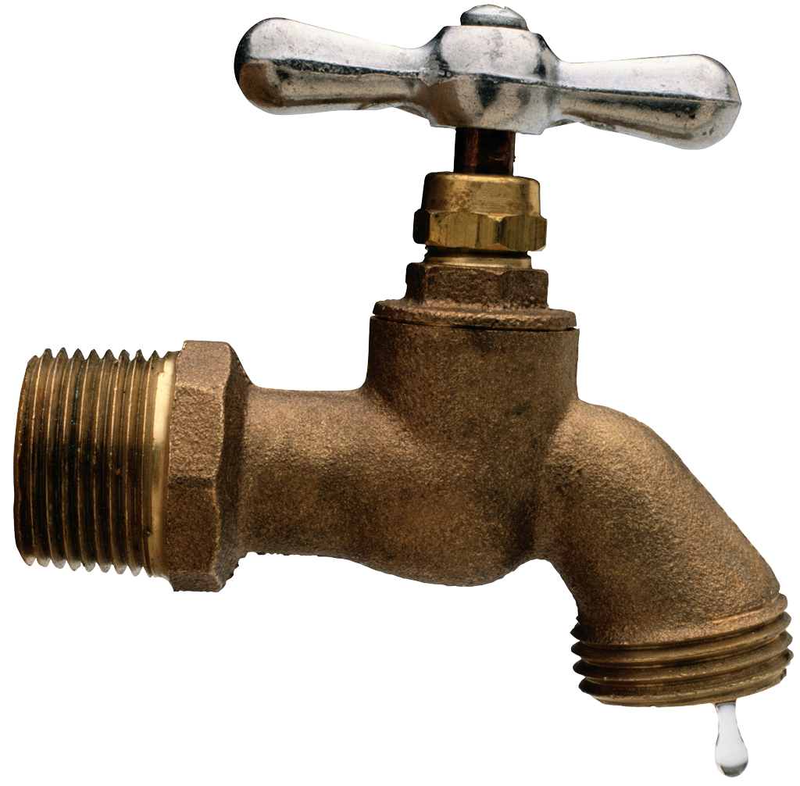
- How many faucets are in the room? ______ Do they turn off automatically? ___YES ___NO

How many of the faucets are leaky? _______

Are there signs reminding people to turn off the water? ___ Yes ___No

BATHROOMS
Location of Bathroom____________________________
- How many faucets are in the bathroom? ______ Do the faucets turn off automatically? ___YES ___NO

- How many of the faucets are leaky? _______

- Are there signs reminding students to turn off the water? ___ Yes ___No

- How many toilets leak or run? _____________

- How many urinals are in the bathroom? ________ Are they waterless? ___________

WATER FOUNTAINS – Location (ex. Hallway, cafeteria, etc.): ____________________________
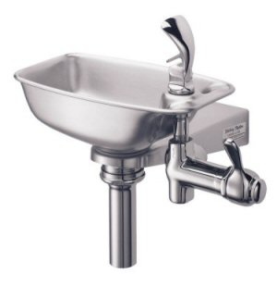

- How many water fountains are there? _______
- How many water fountains are leaky? ________
- How many of the water fountains don’t work? _________
OUTDOOR WATER USE
9. Is there a rain barrel? ___ YES ___NO If yes, what is it used for?

10. Ask your custodian or facilities person who waters the garden. Is drip irrigation used to water plants outside?
___ YES ____NO

How often is the garden watered?

11. Walk around the schoolyard and check out the plants. Ask a teacher if there any plants that require less water in the schoolyard? (These are called drought-tolerant plants).

Please share ONE IDEA for how your school could save more water.

