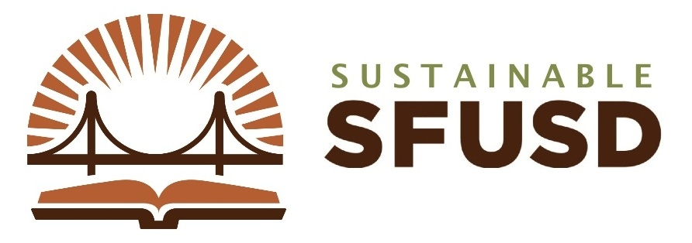
GREEN BACK-TO-SCHOOL
Dear Parents,

SFUSD has successfully adopted green cleaning chemicals and recycled content paper products to reduce the District’s ecological footprint while providing an enhanced learning environment for our students.

YOU can help us to reach our healthy school goals by greening your back-to-school purchases. By purchasing products that have a positive impact on human health and the environment, your are helping to ensure that your child has good indoor air quality, limited exposure to toxic chemicals, and produces less waste.
Did you know that if you use a disposable lunch, you create between 4-8 oz. of garbage everyday? At a school, this can add up to nearly 20,000 pounds of garbage per year!
- REUSE backpacks, binders, notebooks, pencils, markers, and all other items that are still in good shape. You can also check out SCRAP–SF.org for materials and art supplies.
- RECYCLE clothing and buy USED gently-worn items at numerous fashionable and funky stores in SF. Chloe’s Closet and Goodwill are local favorites.
- REUSE whiteboard markers by purchasing the refillable kind and re-using them for years!

- REUSE the blank side of scrap paper for writing/drawing projects.

SAVE MONEY and RESOURCES
DID YOU KNOW 14 billion pencils are produced every year, many made with wood from ancient forests.
- Buy locally-grown foods, organic if possible.
- Buy products with the least amount of packaging or with packaging made from recycled materials.
- Pack food in reusable containers (or sack) and use reusable water bottles and cloth napkins that can be washed.

PACK a WASTE-FREE, TOXICS-FREE LUNCH

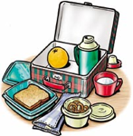
Look for notebooks, art supplies, paper, and other products with the following labels:
- “Less-Toxic” – free of PVC (#3), styrene (#6), or polycarbonate plastic (#7).
- Forest Stewardship Council (FSC) – uses
sustainably harvested wood.
- Approved Product (AP) – safe art and creative products.
- Recycled – has recycled content (symbol filled in).
- Green Seal or EcoLogo – environmentally preferable products in a variety of categories.
- Reusable – can be used over and over again.
GREEN SUPPLIES – HOW DO I KNOW ITS GREEN?
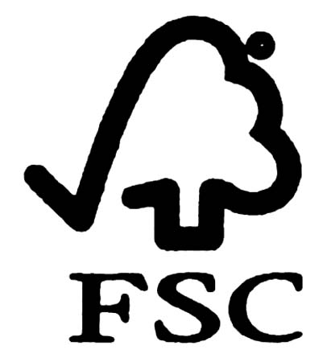
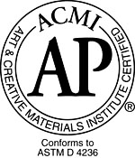
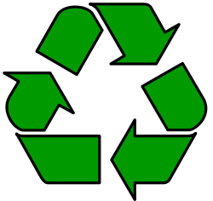
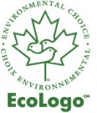
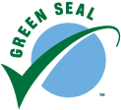
Some estimates suggest that 400 million used whiteboard markers - that's 25,000 tons - are thrown out in U.S. schools every year, ending up in landfills.
Source: www.GreenSchools.net
The average American consumes about 660 pounds of paper per year, compared to 550 pounds in Japan and only about 8.8 pounds in India.

To learn more about choosing environmentally responsible products and services, visit the following website:
- Green Schools Initiative, www.greenschools.net/buyingguide
If you’re interested in SFUSD’s Sustainable Operations and Ecoliteracy programs, visit:
- Green the Next Generation, www.greenthenextgen.org

Sustainably Yours,
Nik Kaestner
Director of Sustainability
415.241.4327
KaestnerN@sfusd.edu

